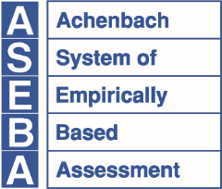
ASEBA®
Research Center for Children, Youth & Families, Inc., a Non-Profit Corporation
1 S. Prospect Street, MS 331, Burlington, VT 05401-3456
aseba.org | 802.656.5130 | mail@aseba.org

Request for ASEBA Training

Please complete the form below and email it to mail@aseba.org. You may also mail the form to: ASEBA, One South Prospect Street, Burlington, VT 05401-3456. Use additional sheets if necessary.

Name: | Organization:
Street Address:
2nd Street Address:
City: | State: | Zip/Postal Code:
Country: | Phone:
Email:
What kind of training do you wish to have:

Professions, backgrounds, & types of work done by trainees:
What do your trainees know about ASEBA?
Please describe your goals for the training:
Approximately how long would you like the training to be? What dates?
Online On location (City/Town/State): ____________________________
Approximately how many people would attend the training?
By approximately what date do you need a commitment?
Thank you!

