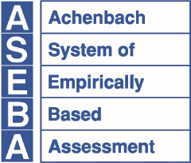
ASEBA®
Research Center for Children, Youth & Families, Inc., a Non-Profit Corporation
1 S. Prospect Street, MS 331, Burlington, VT 05401-3456
aseba.org | 802.656.5130 | mail@aseba.org

Application for Discount on ASEBA Materials to Be Used in Student Research Projects

Please complete this form and send it to mail@aseba.org. The professor or dissertation advisor’s signature is required. You may also mail the form to: ASEBA, One South Prospect Street, Burlington, VT 05401-3456

Please complete the information below and obtain the professor or faculty advisor’s signature.
Title of Academic Course/Program (e.g. Master’s or Ph.D.):
University or Educational Institution:
Please provide a detailed description of coursework or dissertation details, research subjects, and specific research use of materials. (Please attach additional sheets if necessary):

Student Information
Name:
Street Address: |  | Street Address (2nd line):
City: |  | State: | Zip/Postal Code:
Country: |  | Phone:
Email:
Faculty Member Supervising this Project
Name: |  | Title:
Signature: |  | Organization:
Department: |  | Street Address:
2nd Street Address: |  | City:
State: | Zip/Postal Code: |  |  | Country:
E-mail: |  | Phone:
Please state the specific materials you are requesting and the quantity of each that is needed:
(Please note that Starter Kits and are not eligible for discounts as they are already reduced. In addition, ASEBA-Web and e-unit packages are not eligible for discounts.)

